The Cask of Amontillado by Edgar Allan Poe
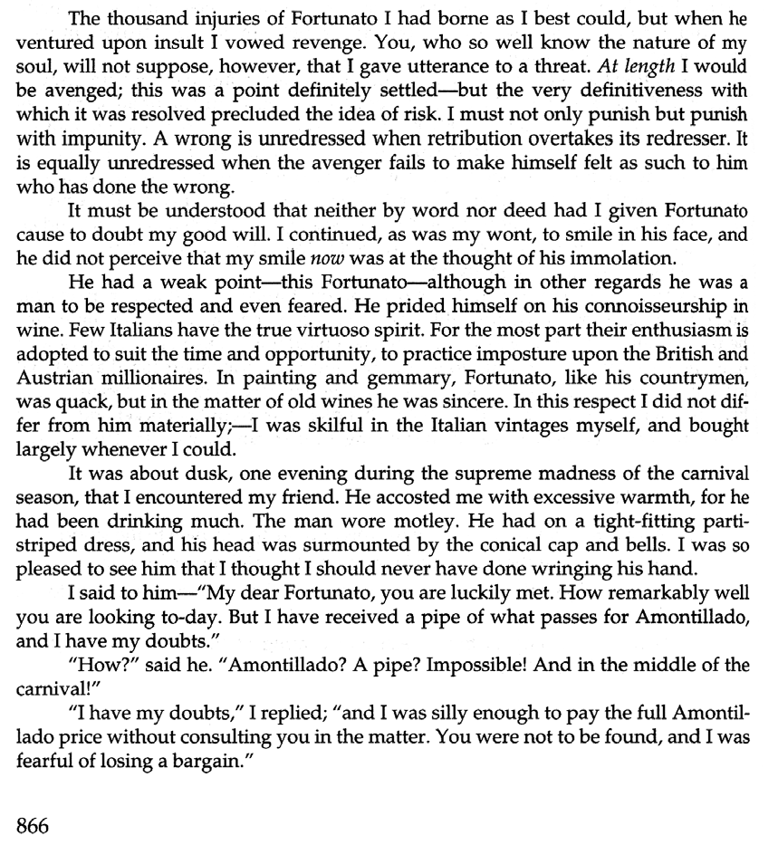

"Amontillado!"
"I have my doubts." "Amontillado!"
"And I must satisfy them." "Amontillado!"
"As you are engaged, I am on my way to Luchresi. If any one has a critical turn, it is he. He will tell me "
"Luchresi cannot tell Amontillado from Sherry."
"And yet some fools will have it that his taste is a match for your own." "Come, let us go."
"Whither?"
"To your vaults."
"My friend, no; I will not impose upon your good nature. I perceive you have an engagement. Luchresi---"
"Ihave no engagement;-come."
"My friend, no. It is not the engagement, but the severe cold with which I per­ ceive you are afflicted. The vaults are insufferably damp. They are encrusted with niter."
"Let us go, nevertheless. The cold is merely nothing. Amontillado! You have been imposed upon. And as for Luchresi, he cannot distinguish Sherry from Amon­ tillado."
Thus speaking, Fortunato possessed himself of my arm; and putting on a mask of black silk and drawing a raquelaire0 closely about my person, I suffered him to hurry me to my palazzo.
There were no attendants at home; they had absconded to make merry in honor of the time. I had told them that I should not return until the morning, and had given them explicit orders not to stir from the house. These orders were suffi­ cient, I well knew, to insure their immediate disappearance, one and all, as soon as my back was turned.
I took from their sconces two flambeaux, and giving one to Fortunato, bowed him through several suites of rooms to the archway that led into the vaults. I passed down a long and winding staircase, requesting him to be cautious as he followed. We came at length to the foot of the descent, and stood together on the damp ground of the catacombs of the Montresors.
The gait of my friend was unsteady, and the bells upon his cap jingled as he strode.
"The pipe?" said he.
"It is farther on," said I; "but observe the white web-work which gleams from these cavern walls."
He turned towards me, and looked into my eyes with two filmy orbs that dis-
tilled the rheum of intoxication . "Niter?" he asked at length.
"Niter," I replied. "How long have you had that cough?"
"Ugh! ugh! ugh!-ugh! ugh! ugh!-ugh! ugh! ugh! ugh! ugh! ugh!-ugh! ugh!
ugh!"
My poor friend found it impossible to reply for many minutes.
"It is nothing," he said, at last.

roquelaire: A heavy cloak.

"Come," I said, with decision, "we will go back; your health is precious. You are rich, respected, admired, beloved; you are happy, as once I was. You are a man to be missed. For me it is no matter. We will go back; you will be ill, and I cannot be responsible. Besides, there is Luchresi- - "
"Enough," he said; "the cough is a mere nothing; it will not kill me. I shall not die of a cough."
"True-true," I replied; "and, indeed, I had no intention of alarming you un­ necessarily-but you should use all proper caution. A draft of this Medoc will de­ fend us from the damps."
Here I knocked off the neck of a bottle which I drew from a long row of its fel­ lows that lay upon the mold.
"Drink," I said, presenting him the wine.
He raised it to his lips with a leer. He paused and nodded to me familiarly, while his bells jingled.
"I drink," he said, "to the buried that respose around us." "And I to your long life."
He again took my arm, and we proceeded. "These vaults," he said, "are extensive ."
"The Montresors," I replied, "were a great and numerous fam ily." "I forget your arms."
"A huge human foot d'or, in a field azure; the foot crushes a serpent rampant whose fangs are imbedded in the heel."
"And the motto?"
"Nemo me impune lacessit."0
"Good!" he said.
The wind sparkled in his eyes and the bells jingled. My own fancy grew warm with the Medoc. We had passed through long walls of piled skeletons, with casks and puncheons intermingling, into the inmost recesses of the catacombs. I paused again, and this time I made bold to seize Fortunato by an arm above the elbow.
"The niter!" I said; "see, it increases. It hangs like moss upon the vaults. We are below the river's bed. The drops of moisture trickle among the bones. Come, we will go back ere it is too late. Your cough - - - "
"It is nothing," he said; "let us go on. But first, another draft of the Medoc."
I broke and reached him a flagon of De Grave. He emptied it at a breath. His eyes flashed with a fierce light. He laughed and threw the bottle upward with a ges­ ticulation I did not understand.
I looked at him in surprise. He repeated the movement-a grotesque one. ''You do not comprehend?" he said.
"Not I," I replied.
"Then you are not of the brotherhood." "How?"
"You are not of the masons." "Yes, yes," I said; "yes, yes." "You? Impossible! A mason?" "A mason," I replied.
"A sign," he said, "a sign."
"It is this," I answered, producing from beneath the folds of my roquelaire a trowel.

Nemo me impune lacessit: "No one harms me unpunished."

"You jest," he exclaimed, recoiling a few paces. "But let us proceed to the Amon tillado."
"Be it so," I said, replacing the tool beneath the cloak and again offering him my arm. He leaned upon it heavily. We continued our route in search of the Amon­ tillado. We passed tl)rough a range of low arches, descended, passed on, and de­ scending again, arrived at a deep crypt, in which the foulness of the air caused our flambeaux rather to glow than flame.
At the most remote end of the crypt there appeared another less spacious. Its walls had been lined with hwnan remains, piled to the vault overhead, in the fash­ ion of the great catacombs of Paris. Three sides of this interior crypt were still ornamented in this manner. From the fourth the bones had been thrown down, and lay promiscuously upon the earth, forming at one point a monnd of some size. Within the wall thus exposed by the displacing of the bones, we perceived a still interior crypt or recess, in depth about four feet, in width three, in height six or seven. It seemed to have been constructed from no especial use within itself, but formed merely the interval between two of the colossal supports of the roof of the catacombs, and was backed by one of their circumscribing walls of solid granite.
It was in vain that Fortunato, uplifting his dull torch, endeavored to pry into
the depth of the recess. Its termination the feeble light did not enable us to see. "Proceed," I said; "herein is the Amontillado. As for Luchresi--" "Heisanignoramus," interrupted my friend, as he stepped unsteadily for­
ward, while I followed immediately at his heels. In an instant he had reached the ex­ tremity of the niche, and finding his progress arrested by the rock, stood stupidly bewild ered . A moment more and I had fettered him to the granite. In its sµrface were two iron staples, distant from each other about two feet, horizontally. From one of these depended a short chain, from the other a padlock. Throwing the links about his waist, it was but the work of a few seconds to secure it. He was too much astonnded to resist. Withdrawing the key I stepped back from the recess.
"Pass your hand," I said, "over the wall; you cannot help feeling the niter. In­ deed it is very damp. Once more let me implore you to return. No? Then I must posi­ tively leave you. But I must first render you all the little attentions in my power."
"The Amontillado!" ejaculated my friend, not yet recovered from his astonish-

"True," I replied; "the Amontillado."
As I said these words I busied myself among the pile of bones of which I have before spoken. Throwing them aside, I soon uncovered a quantity of building stone and mortar . With these materials and with the aid of my trowel, I began vigorously to wall up the entrance of the niche.
I had scarcely laid the first tier of the masonry when I discovered that the in­ toxication of Fortunato had in a great measure worn off. The earliest indication I had of this was a low moaning cry from the depth of the recess. It was not the cry of a drunken man. There was then a long and obstinate silence. I laid the second tier, and the third, and the fourth; and then I heard the furious vibrations of the ch ain . The noise lasted for several minutes, during which, that I might hearken to it with the more satisfaction, I ceased my labors and sat down upon the bones. When at last the clanking subsided, I resumed the trowel, and finished without interruption the fifth, the sixth, and the seventh tier. The wall was now nearly upon a level with my breast. I again paused, and holding the flambeaux over the masonwork, threw a few feeble rays upon the figure within.

A succession of loud and shrill screams, bursting suddenly from the throat of the chained form, seemed to thrust me violently back. For a brief moment I hesi­ tated, I trembled. Unsheathing my rapier, I began to grope with it about the recess; but the thought of an instant reassured me. I placed my hand upon the solid fabric of the catacombs, and felt satisfied. I reapproached the wall. I replied to the yells of him who clamored. I reechoed, I aided, I surpassed them in volume and in strength. I did this, and the clamorer grew still.
It was now midnight, and my task was drawing to a close. I had completed the
eighth, the ninth and the tenth tier. I had finished a portion of the last and the eleventh; there remained but a single stone to be fitted and plastered in. I struggled with its weight; I placed it partially in its destined position. But now there came from out the niche a low laugh that erected the hairs upon my head. It was suc­ ceeded by a sad voice, which I had difficulty in recognizing as that of the noble For­ tunato. The voice said-
"Ha! ha! ha!-he! he! he!-a very good joke, indeed-an excellent jest. We will have many a rich laugh about it at the palazzo-he! he! he!---over our wine-he! he! he!"
"The Amontillado!" I said.
"He! he! he!-he! he! he!-yes, the Amontillado. But is it not getting late? Will not they be awaiting us at the palazzo, the Lady Fortunato and the rest? Let us be gone."
"Yes," I said, "let us be gone."
"For the love of God, Montresor!"
"Yes," I said, "for the love of God!"
But to these words I hearkened in vain for a reply. I grew impatient. I called aloud­
"Fortunato!"
No answer. I called again­ "Fortunato!"
No answer still. I thrust a torch through the remaining aperture and let it fall within. There came forth in return only a jingling of the bells. My heart grew sick; it was the dampness of the catacombs that made it so. I hastened to make an end of my labor. I forced the last stone into its position; I plastered it up. Against the new ma­ sonry I re-elected the old rampart of bones. For the half of a century no mortal has disturbed them. In pace requiesact!0

QUESTIONS
- How is the setting expressive of the theme?
- What is the significance of Montresor's name, dress, coat of arms, and fam­ ily motto?
- What are the aspects of Fortunato's character that victimize him?
- What is the tone of Fortunato's "For the love of God, Montresor ! " and of Mon­ tresor's reply? What is the significance in the story of this exchange?
- Is the final "In pace requiescat!" ironic?

In pace requiescat!: Rest in peace!

“The Cask of Amontillado” by Edgar Allan Poe

from Charters, Ann, Ed. The Story and its Writer: An Introduction to Short Fiction. 6th Ed. Boston: Bedford/St. Martin’s, 2003.

