"Girl"

by Jamaica Kincaid
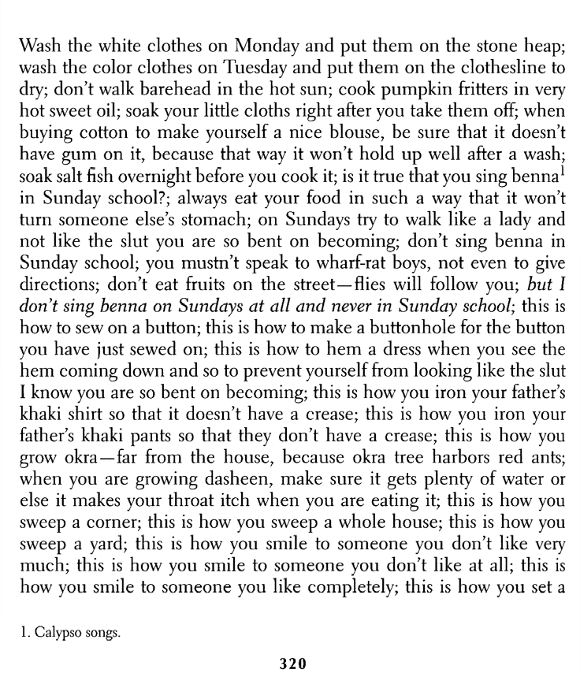

Girl ■ 321

table for tea; this is how you set a table for dinner; this is how you set a table for dinne r with an important guest; this is how you set a table for lunch; this is how you set a table for breakfast; this is how to beha ve in the presence of men who don 't know you very well, and this way they won't recognize imm edia tely the slut I have warned you against becoming; be sure to wash every day, even if it is with your own spit;, don 't squat down to play marb le s- you are not a boy, you know; don' t pick peopl 's flowe rs- yo u might catch something; don't throw stones at blackbirds, because it might not be a blackbird at all; this is how to make a brea d pudding; this is how to make doukona; this is how to make pepper pot; this is how to make a good medicine for a cold; this is how to make a good medicine to throw away a child before it even becomes a child; th is is how to catch a fish; this is how to throw back a fish you don't like, and that way something bad won't fall on you; th is is how to bully a man; this is how a man bullies you; this is how to love a man, an d if this doesn't work there are other ways, and if they don't work don't feel too bad about giving up; this is how to spit up in the air if yo u feel like it , and this is how to move quick so that it doesn' t fall on you; this is how to make ends meet; always squeeze bread to make sure it's fresh; but what if the baker won't let me feel the bread?; you mean to say that after all yo u are really going to be the kind of woman who the baker won't let near the bread?

• • •
“Girl” by Jamaica Kincaid

from Charters, Ann, Ed. The Story and its Writer: An Introduction to Short Fiction. 6th Ed. Boston: Bedford/St. Martin’s, 2003.
1983

