Writing About Comics and Graphic Novels

Visual Rhetoric/Visual Literacy Series

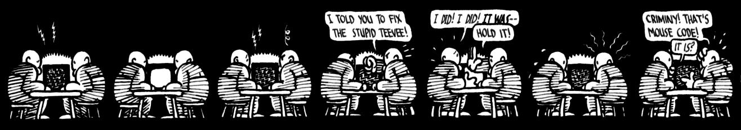

Whether in the Sunday paper or a critically acclaimed graphic novel, comics have been a staple of American culture since the turn of the last century. Only recently, however, have scholars begun turning any sustained attention to comics as an art form, a specific print medium, and a cultural artifact. For this reason, many of us are familiar with the basics of reading comics, but not with any critical vocabulary for deciphering or discussing them. This handout offers advice on how to approach the medium of comics.

Overview: What are Visual Rhetoric and Visual Literacy?

The simplest definition for visual rhetoric is how/why visual images communicate meaning. Note that visual rhetoric is not just about superior design and aesthetics but also about how culture and meaning are reflected, communicated, and altered by images. Visual literacy involves all the processes of knowing and responding to a visual image, as well as all the thought that might go into constructing or manipulating an image.

What are Comics?

Comics are easy to recognize but difficult to define. Will Eisner used the term “sequential art” to describe comics, a definition later modified by Scott McCloud into “juxtaposed pictorial and other images in deliberate sequence” (McCloud 9). The focus in each of these definitions is sequence: a string of images that are read one after another to produce meaning. Comics may or may not incorporate text, and differ from single cartoons by producing a more complicated pattern (most often narrative) through sequential spatial arrangement. This may sound unnecessarily complicated to describe what Popeye is up to this week, but such linguistic complication speaks to the difficulty of defining something that we often read intuitively rather than intellectually.

The basic building blocks of comics are panels, single frames placed in sequence. Usually these panels have rectangular borders, but panels can have any shape, or even no border at all, as long as there is some sign of where one might end and another begin. Outside the borders is a (usually) blank area known as the gutter. Each panel will usually contain pictorial images of some sort, including but not limited to drawings, paintings, photographs, text, speech and thought balloons, and text boxes. Panels generally read in the same sequence as text (i.e., in Western countries left to right, then top to bottom).

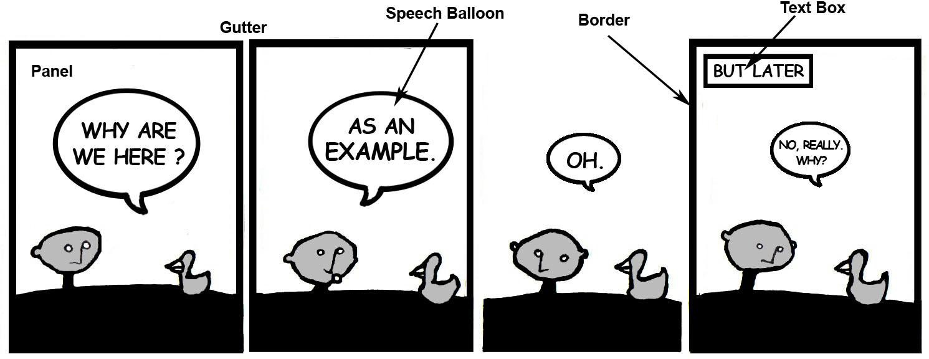

When approaching sequential art, try to keep an open mind, since anything and everything on the page can contribute to the overall meaning. To make the task easier, you might try breaking the kinds of visual information you are getting down into their components: page layout, art and art style, and text/image interaction.

Page Layout

With comics, as with most things, how narrative information is presented is often as important as what that information is. Page layout may seem entirely neutral; just remember, even this neutrality is an effect. Even if the page is comprised of uniform rectangles in an obvious and regular order, that layout was still chosen by the artist to create an impression. It might be a way of focusing your attention on what is happening rather than on how it is depicted; it may even reinforce a theme of conformity, repetition, or boredom. Alternatively, artists like Chris Ware often create ornate pages with arrows leading in multiple directions to create a sense of the complexity of personal history and memory. If the border of the first panel of the strip at the top of this page were a heart rather than a rectangle, how might that change the meaning of the strip?

When you approach a page, try asking yourself the following questions:

- How is the page organized?
- Is the panel order obvious, and how do you know the intended order?
- Are the panels and borders uniform in shape and size, or do they vary?
- If they vary, how, and how does this affect the meaning?

Art Style

Analyzing style is probably the most difficult aspect of analyzing comics, since there are so few guidelines for talking about different types of drawing. In Understanding Comics, Scott McCloud has done an admirable job of discussing different forms of abstraction in cartooning and how these can affect meaning (24-59). Even with a guidebook, though, you will still need to trust your own impressions, since there are no set rules for how different art styles create meaning. The terminology of film studies is often useful for describing the basic features of an image, since you can talk about long shots, close ups, or zooms to describe the various angles and points of view depicted. Think about what sort of art the artist uses:

- Is there color, and, if so, what is the palate?
- Is the style cartoonish, abstract, photo-realistic, etc.?
- What does that tell you about the world the creator(s) are depicting?
- Are there backgrounds? If so, are they detailed or schematic?
- Does the point of view remain constant (as in the example above), or does it vary? If so, how?
- Does the art focus your attention on particular actions? How?

Text and Image

Not all comics include text, but many do. Text in comics can serve as dialogue, narration, sound effect, commentary, clarification, image, and more. Once again, context is key, since you often can’t tell what a piece of text is doing on a page without determining how it relates to the images it accompanies (and is part of). Here is an example of image and text interacting to create a complex whole:
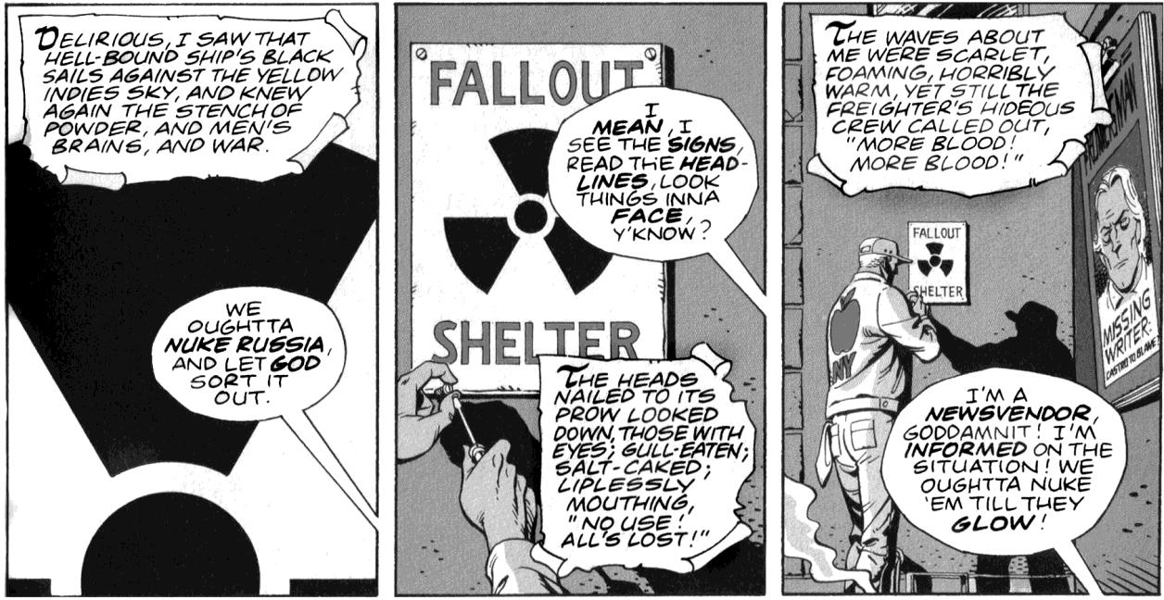
Alan Moore and David Gibbon. Watchmen. New York: DC Comics, 1987. Chapter III, page 1.

These are the first three panels of the third issue of Watchmen. Without any text, the panels would simply depict a man hanging a sign, pushing back from the extreme close-up in panel one to a medium shot of the same action in panel three. With the text, however, the panels develop a complicated interplay of different elements. There are three distinct types of text here: the text boxes, the speech balloons, and the sign and clothing text.

- The text boxes contain narration from a pirate comic book, which we discover a panel later is being read by a teenage boy at a newsstand. The language and shape of the text boxes indicate their distance from the principal narration, but the parallel text provides an ironic commentary on the main scene.
- The speaker behind the speech balloons is indicated in the third panel: a newsvendor expressing his fear and anger about the cold war. Notice how some words (“nuke Russia,” “God,” “mean,”
“signs,” headlines,” “face,” “newsvendor,” “informed,” and “glow”) are bolded, giving a sense of spoken emphasis and volume.

- Finally, the sign text is an instance of text as image. While the “Fallout Shelter” text simply mirrors the non-verbal icon on that sign, the “Missing Writer” sign in the third panel gestures toward another part of the narrative (the writer turns out to be a character, introduced several issues later). The “NY” under the apple on the workman’s jacket places the scene quickly.

More important than any of these three in isolation, however, is how they all work together. The horrifying imagery of the pirate story gives a mediated image of the potential destruction of nuclear war endorsed by the newsvendor’s dialogue, while the likelihood of such a war is given iconic reference through the fallout shelter sign. Not all comics feature this degree of ironic interplay between different types of text and image, but the example shows some of the ways that text and image can interrelate.

Recommended Texts

Eisner, Will. Comics & Sequential Art. New York: Poorhouse Press, 1985.

Although directed more at artists than academics, Will Eisner’s Comics & Sequential Art was one of the earliest books to look at the mechanics of sequential art (a term coined by Eisner). He has also written a companion (Graphic Storytelling and Visual Narrative. New York: Poorhouse Press, 1996) focused specifically on narrative.

McCloud, Scott. Understanding Comics: The Invisible Art. New York: Harper Perennial, 1994.

This book, a primer for readers, creators, and students of comics, has become the default handbook for those interested in studying or analyzing comics. Presented in comic form, Understanding Comics offers a wealth of examples and analyses of different aspects of comics, tied together with McCloud’s often polemical musings on the nature and future of the medium.

Helpful Links

The Edwin and Terry Murray Comic Book Collection http://library.duke.edu/digitalcollections/rbmscl/murraycomics/inv/
This is a huge archive of comics from the 1930s through 2001, located in the Duke University Rare Book, Manuscript, and Special Collections Library. Duke University Libraries also has a strong collection of graphic novels and non-fiction in its regular catalog.

The Grand Comics Database Project http://www.comics.org/
A volunteer-maintained, searchable database of comics, this site is useful for locating primary materials or historical background.

Comics Research http://www.comicsresearch.org/
This annotated bibliography site for comics research is regularly updated, and contains subsections on different aspects of research into comics. The first subsection, “Comics in General,” is of particular interest to those looking for more academic resources on comics.

Shared from Duke Writing Studio

The banner image at the beginning of the handout is from Chris Ware, Quimby the Mouse (Seattle: Fantagraphics Books, 2003), 14.

