“A healthy diet is cheaper than junk food but a good diet is still too expensive for some”

By Amanda Lee

May 24, 2016 9.36pm EDT
Many people believe eating healthily is expensive – and more costly than buying junk food. But our new research, published in the journal BMC Public Health, shows this isn’t the case.
Most Australian households’ food budget is being spent on “discretionary” or “junk” foods and drinks that are high in saturated fat, added sugar, salt and/or alcohol. Eating a healthy diet, as recommended by the Australian Dietary Guidelines, would be cheaper.
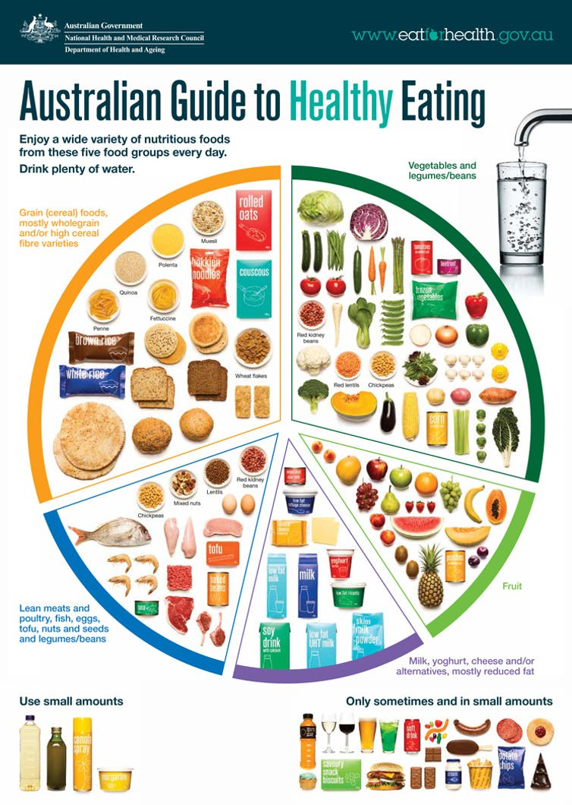
Australia’s Dietary Guidelines. eatforhealth.gov.au
Less than 7% of Australians follow these guidelines. The average Australian adult derives at least 35% of their energy intake from “junk” foods and drinks. As a result, two-thirds of adults (63%) and one-quarter of children are overweight or obese.

Comparing diets
We used the Australian Health Survey 2011-13 and the recommendations of the Australian Dietary Guidelines to model current and healthy diets for a family of two adults and two children (plus for other common household makeups) per fortnight.

Analysis of the world, from experts
We collected food prices in supermarkets and stores in randomly selected high- and low-socioeconomic areas in Brisbane, and compared the diet prices with household incomes.
In both areas, a family of two adults and two children spend about 18% more on current diets than would be required to purchase healthy (recommended) diets. About 58% of the food budget for the current diet is spent on “junk”, including take-away foods (14%), alcohol (12%) and sugary drinks (4%).
In the low-socioeconomic area, a family of two adults and two children spend A$640.20 per fortnight on their current diet, but could buy a healthy diet for A$560.93 per fortnight. In the high-socioeconomic area, these figures were A$661.92 and A$580.01 respectively.
Supermarket retail food prices were on average 3% higher in the high-socioeconomic location. Take-away foods were also relatively more expensive, but alcoholic drinks and sugar-sweetened beverages were priced similarly in both areas.
The bad news is that a healthy diet costs 20-31% of the disposable income of low-income households. An acceptable benchmark of affordability is around 30%. So these results confirm that healthy diets can be unaffordable for the most vulnerable in our society.

What can be done?
Current diets cost more than healthy diets, so factors other than price must be helping drive preference for unhealthy choices. These likely include the ubiquitous availability, accessibility, advertising and promotion of junk foods that exploit people’s vulnerabilities. It’s therefore important not to blame victims for responding as expected to unhealthy food environments.
Rather, to help break these vicious cycles, nutrition policy actions must tackle barriers to healthy eating. Ways to do this include increasing availability of healthy foods and drinks in schools and hospitals and regulating against “junk” food and drink advertising directed to children. Together, these small steps can help shift the whole population to a healthier diet.
It is also important not to increase barriers by making healthy foods and drinks less affordable, such as by expanding the GST to include basic, healthy foods. Our study shows that, if this happened, the cost of a healthy diet for a family of two adults and two children would increase by around A$56.39 per fortnight.
Conversely, fiscal policy actions such as increased taxation of sugar-sweetened drinks, which was announced recently in the United Kingdom, can play an important role in efforts to improve diets and reduce the risk of diet-related disease.
We know this from Mexico, where sugary drinks have been taxed for more than a year and sales are down by 12%. Importantly, in Mexico the biggest reductions in consumption have occurred among the poor, who inequitably suffer the highest rates of diet-related chronic disease but can least afford health care.
Poor diet is now the number one preventable risk factor contributing to the burden of disease in Australia. Urgent action is needed.

